Low GI/GL (Glycaemic Index/Glycaemic Load) Diet

***Why this diet?***

A low Glycaemic Index/load diet will help minimise the rise in blood sugar (glucose) and insulin from the food you've eaten. Constant rises of blood sugar and insulin levels are involved in the cause and worsening of many health issues and diseases, so we want to avoid this.

*It helps to:*

* Keep blood sugar levels more consistent
* Prevent insulin resistance and diabetes
* Promote a healthy weight
* Lower cholesterol
* Lower heart disease risk
* Lower risk of other diseases

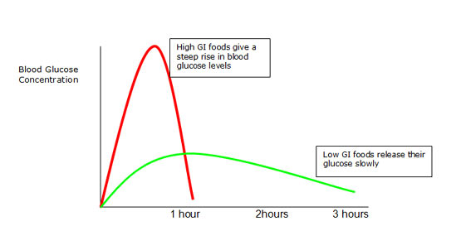

***What is Glycaemic Index (GI)?***

* The measurement of a foods ability to increase your blood sugar

***What is Glycaemic Load (GL)?***

* The measurement that a food will increase your blood sugar in a common serving
* This takes into account both the glycaemic index and the amount of carbohydrate in that food

***Should I pay more attention to GI or GL?***

* GL is more important to pay attention to when considering blood sugar levels.
* For example, carrots are high in GI but low in GL. They only contain a small amount of carbohydrates within them, meaning they will not raise blood sugar significantly.

**Tip:**Proteins and fats will not spike your blood sugar like carbohydrates will. These foods should make up majority of your diet if blood sugar or insulin spikes are an issue.

***What should I eat?***

|  |  |
| --- | --- |
| *Eat These* | *Avoid These* |
| * High protein and healthy fat foods   + Organic meat and seafood   + Eggs   + Avocado, coconut (and their oils) * High fibre/Low carbohydrate fruits and vegetables:   + Leafy greens   + Pumpkin   + Broccoli   + Carrots   + Apples   + Oranges   + Cherries   + Berries   + Green peas and beans   + Mushrooms   + Most other vegetables excluding potatoes and parsnips * High fibre, low sugar cereals * Nuts and seeds * Unsweetened yoghurt * Lentils and beans | * Soft drinks (and other high sugar drinks) * Lollies and chocolate * Cakes, biscuits and desserts * Fruit juice * White rice * White pasta * White bread * Couscous * Chips and baked potatoes * Low-fiber and sweetened cereals * Pizza * Dates and raisins * Ice-cream |

***Food Swaps***

These dietary changes can be challenging and confusing, so here's some ideas of some good food swaps.

|  |  |  |
| --- | --- | --- |
| * Unsweetened Muesli * Oats | Instead of | * Sweetened Cereal |
| * Wholegrain Bread * Wholemeal Bread * Soy & Linseed Bread * Low GI bread | Instead of | * White Bread |
| * Basmati Rice * Brown Rice | Instead of | * White rice |
| * Sweet potato | Instead of | * White potato |
| * Water * Smoothie with whole fruit | Instead of | * Soft drinks * Fruit Juice |

***Additional Tips***

* To heavily reduce GI/GL, proteins and fats, rather than carbohydrates should be your main food sources.
* Pair carbohydrates with fibre, protein, or fat to slow their release and minimise blood sugar spikes.
* Smaller portions of foods more often can help to minimise blood sugar spikes and stabilise blood sugar levels